202. Happy Number

Write an algorithm to determine if a number is "happy".

A happy number is a number defined by the following process: Starting with any positive integer, replace the number by the sum of the squares of its digits, and repeat the process until the number equals 1 (where it will stay), or it loops endlessly in a cycle which does not include 1. **Those numbers for which this process ends in 1 are happy numbers.**

Example: 19 is a happy number

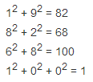

Java 解决算法

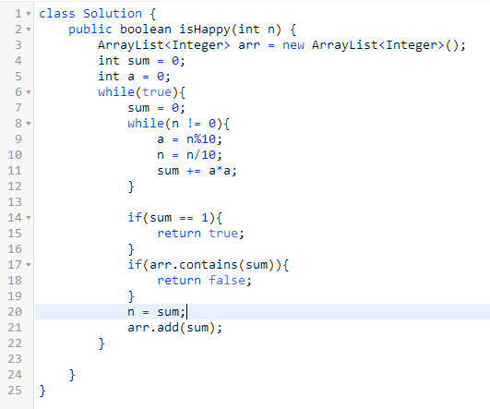

class Solution {

public boolean isHappy(int n) {

ArrayList<Integer> arr = new ArrayList<Integer>();

int sum = 0;

int a = 0;

while(true){

sum = 0;

**while(n != 0){**

**a = n%10;**

**n = n/10;**

**sum += a*a;**

**}**

if(sum == 1){

return true;

}

if(arr.contains(sum)){

return false;

}

n = sum;

arr.add(sum);

}

}

}